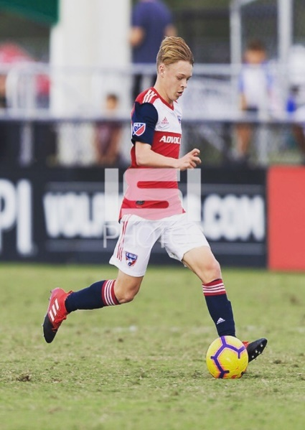
AYDEN NOCUS

Contact and Personal Information:
628 Kimblewick Drive
Frisco, Texas 75036
Cell: 859-613-3980
Email: aydennocus@yahoo.com
Date of Birth: 1/3/2002
Lonestar High School, Frisco, Texas
Class of 2020

Playing History and Accomplishments:

- Current team: FC Dallas USSDA U19 #36
- 2014- 2020 FC Dallas MLS Developmental Academy
- Generation Adidas Cup (GA) Toronto, Canada
- US Soccer National Team Training Center call up
- Feyenoord Youth Academy, Netherlands. Trialist and team invite.
- Vitesse Youth Soccer, Netherlands. Trialist and team invite.
- Feyenoord camp Top 11 player award
- Monterrey Friendlies, Monterrey Mexico
- Copa Chivas, Guadalajara Mexico Finalist
- 2015-2017 Dallas cup Participant (Academy played up an age division)

Positions Played:

I have played various positions which include midfielder (#10, #8) and forward (#9)

Current/Recent Soccer Coaches:

Michael Varas, U17 FC Dallas Academy, Head Coach
mvaras@fcdallas.net

Luchi Gonzalez, FC Dallas Youth Academy Director
LGonzalez@fcdallas.net

Chris Hayden, U19 FC Dallas Academy, Head Coach
Chayden@fcdallas.net

Clem Oancea, FC Dallas premier 02, Head Coach
Coancea@fcdallas.net

